PIZZA SALES SQL QUERIES

**A.KPI’S**

1. TOTAL REVENUE:

SELECT SUM(total_price) AS Total_Revenue FROM pizza_sales;

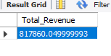

2. AVG_ORDER_VALUE:

SELECT SUM(total_price) / COUNT(DISTINCT order_id) AS avg_order_value FROM pizza_sales;

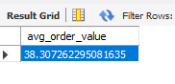

3. TOTAL_PIZZA_SOLD:

SELECT SUM(quantity) AS total_pizza_sold FROM pizza_sales;

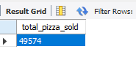

4.Total_ORDER:

SELECT COUNT(DISTINCT order_id) AS Total_order FROM pizza_sales;

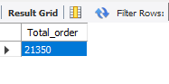

5.AVG_PIZZAS_PER_ORDER:

SELECT CAST(CAST(SUM(quantity) AS DECIMAL(10,2))/

CAST(COUNT(DISTINCT order_id) AS DECIMAL(10,2)) AS DECIMAL(10,2)) AS avg_pizzas_per_order FROM pizza_sales;

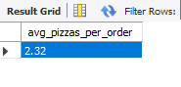

6. TOTAL_ORDERS_WEEK:

SELECT DAYNAME(order_date) AS order_day, COUNT(DISTINCT order_id) AS total_orders FROM pizza_sales

GROUP BY DAYNAME(order_date);

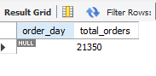

7. TOTAL_ORDERS_HOURS:

ELECT HOUR(order_time) AS order_hours, COUNT(DISTINCT order_id) AS total_orders FROM pizza_sales

GROUP BY HOUR(order_time)

ORDER BY HOUR(order_time);

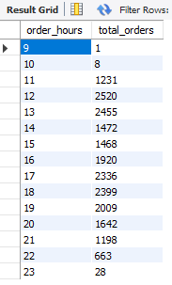

8. PCT:

ELECT pizza_category, SUM(total_price) * 100 / (SELECT SUM(total_price) FROM pizza_sales) AS PCT FROM pizza_sales

GROUP BY pizza_category;

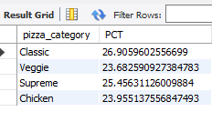

9.TOTAL_PIZZA_SIZE:

SELECT pizza_size, SUM(total_price) as total_sales, SUM(total_price) * 100 /

(SELECT SUM(total_price) FROM pizza_sales) AS PCT

FROM pizza_sales

GROUP BY pizza_size;

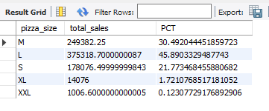

10.TOTAL_PIZZA_SOLD_BY_CATEGORY:

SELECT pizza_category, SUM(quantity) as total_pizzas_sold FROM pizza_sales

GROUP BY pizza_category;

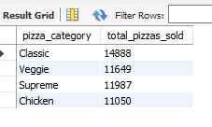

11.TOTAL_PIZZA_SOLD_BY_NAME:

SELECT pizza_name, SUM(quantity) as total_pizzas_sold FROM pizza_sales

GROUP BY pizza_name

ORDER BY SUM(quantity) DESC

LIMIT 5;

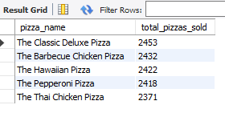

12.